ECE322L - Lab 3

*Common Drain and Common Source MOS Amplifiers*

Roger Holten, David Kirby, Landon Schmucker

**Goal**

We will gain understanding of common drain and common source MOS amplifiers.

# The Lab

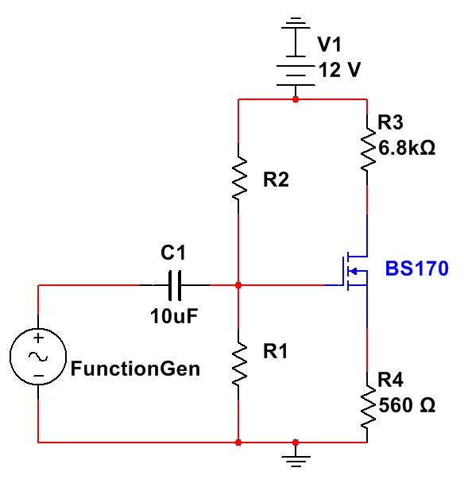

V

D

V

S

***Figure 1: Circuit Diagram.***

## Part 1 – Hand Calculations

Let K’n = 1.825 mA/V^2, (W/L) = 1, VTN = 1 V, IDQ = 790u A, and R1 + R2 = 200K.

1. Find R1 and R2 through hand calculations.
2. Solve for VDSQ and VGSQ. Create the following table to keep track of the measurements.

|  |  |  |  |
| --- | --- | --- | --- |
|  | Hand Calc | Measured | Modelled |
| IDQ | 790 μA | 625 μA | 794 μA |
| VDSQ | 6.628 V | 7.832 V | 6.133 V |
| VGSQ | 1.9305 V | 2.077 V | 1.933 V |
| Gain CS | -6.964 | 8.69 | 5 |
| Gain CD |  | 0.7 | 0.5 |

### Part 2 – Build the Circuit

1. Provide the measured resistances of the resistors.
2. Measure IDQ, VDSQ, and VGSQ with no input from the function generator. Add these to your table.
3. Connect the Oscilloscope’s Channel 1 to your Function generator, and Ch.2 to the Drain.

This makes a Common Source Amplifier.

1. Function Generator setup
   1. Make sure to use the coupling capacitor.
   2. Set Output to High Z. ( Utility -> Output -> High Z )
   3. Frequency = 1K Hz
2. Using the Oscilloscope calculate the Common Source (CS) Gain, add this to the table. Provide a picture of the Oscilloscope screen in your report.
3. Connect channel 2 to the Source node. Calculate the Common Drain (CD) Gain, add this to the table. Provide a picture of the Oscilloscope screen in your report.
4. Provide at least a paragraph on the differences of the CS and CD amplifiers in your report. Some ideas to discuss are: How do the outputs differ? Why are these differences occurring?

### Part 3 – Model the Circuit

1. Create the circuit in your preferred modelling software.

a. Note: If using Multisim, make sure to verify that the model is using the values given above. Otherwise your results will vary greatly!

1. Provide the quiescent values and CS/CD gains in the table.
2. Provide a graph with the two outputs, including the input signal.
3. Compare the differences of the quiescent values obtained in the three different methods.

What could cause the differences?

### Extra Credit (10%) – AC circuit model and analysis

1. Provide the AC circuit diagram.
2. Using your AC circuit, solve for the gain for both common source and common drain amplifiers using variables, then use your measured resistance values to calculate the exact gains and include them in the table.
3. Comment on the differences and contributing factors that may affect the gain between the circuit, model, and hand calculations.

|  |  |
| --- | --- |
| Lab 3 Rubric | |
| Requirement: | Possible Points (100) |
| Part 1: Hand Calculations   1. R1 and R2 solved (10 points) 2. Q-point values (5 points) 3. Resistor and Q-point clearly in the provided table format (5 points) | 20 |
| Part 2: Build the Circuit   1. Measured resistances in clear format (5 points) 2. Circuit Q-points added to provided table (5 points) 3. Circuit Gains (20 points)    1. Gain values added to given table (5/20 points)    2. CS and CD Oscilloscope Pictures with labels (15/20 points) 4. Explanation of differences between CS and CD amplifier (10 points) | 40 |
| Part 3: Model the Circuit   1. Circuit Diagram with nodes labeled (5 points) 2. Q-point values and Gains added to provided table (10 points) 3. One Graph of the CS and CD signals including input signal, with labels (15 points) 4. Comparison of measured, modeled and hand calculations quiescent values (10 points) | 40 |
| Extra Credit   1. AC diagram (2 points) 2. Hand calculation for CS and CD gains (5 points) 3. Comment on difference of gains between measured, modeled and hand calculations (3 points) | 10 extra |